Exploratory Data Analysis (EDA) Report
Objective:To analyze the sales dataset and uncover meaningful patterns, trends, and business insights using statistical analysis, SQL queries, and data visualization techniques.
Dataset Overview
- Total Rows: 1000
- Total Columns: 12
- Dataset Source: ApexPlanet Sales Dataset
Descriptive Statistics
Summary statistics were calculated for Quantity, Unit Price, and Total Sales.
Key Statistics:
- Average Quantity Sold: 5.44
- Average Unit Price: ₹25,486.78
- Average Total Sales: ₹139,399.44
- Maximum Quantity Sold: 10
- Maximum Unit Price: ₹49,997.53
- Maximum Total Sales: ₹493,677.50
- Minimum Quantity Sold: 1
- Minimum Unit Price: ₹145.78
- Minimum Total Sales: ₹437.34
Univariate Analysis
Visualizations Created:
- Histogram of Total Sales
- Histogram of Quantity
- Category Distribution Bar Chart
Findings
- Electronics generated the highest revenue among all categories.
- Sales values are widely distributed, ranging from ₹437 to ₹493,677.
- Most transactions involve quantities between 3 and 8 units.
SQL Business Analysis
Business questions answered:
1. Top 5 Products by Revenue
2. Revenue by Category
3. Average Sales by Category
4. Top Customers by Revenue
5. Monthly Revenue Trend
6. Quantity Sold by Category
7. Top Customers by Orders
Revenue by Category
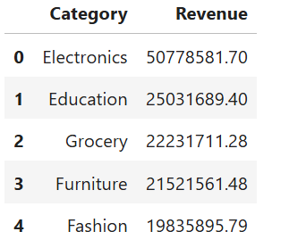
Top Products by Revenue
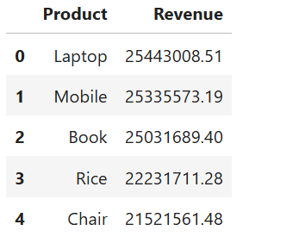
Monthly Revenue Trend
Top Revenue Months:
1. March – ₹13,059,899.94
2. June – ₹12,912,332.64
3. November – ₹12,627,620.22
Lowest Revenue Month:
- September – ₹9,179,896.29
Correlation Analysis
Techniques Used:
- Scatter Plot
- Correlation Heatmap
- Pair Plot
Correlation Matrix Findings
- Quantity vs Total Sales = 0.6466
- Unit Price vs Total Sales = 0.6863
- Quantity vs Unit Price = 0.0219
Interpretation
- Total Sales has a strong positive relationship with both Quantity and Unit Price.
- Quantity and Unit Price are almost independent of each other.
- Unit Price shows the strongest influence on Total Sales.
Dashboard KPIs
- Total Revenue: ₹139,399,439.65
- Total Orders: 1000
- Average Order Value: ₹139,399.44
- Total Categories: 5
- Best Performing Category: Electronics
Key Insights
1. Electronics is the highest revenue-generating category.
2. Laptop is the top-selling product by revenue.
3. March recorded the highest monthly sales revenue.
4. Higher quantities and higher unit prices directly increase total sales.
5. Unit Price has the strongest impact on revenue generation.
Conclusion
The sales dataset was successfully analyzed using descriptive statistics, SQL querying, and exploratory data analysis techniques. Electronics and Laptop products contributed the highest revenue, while March emerged as the best-performing month. The analysis revealed strong positive relationships between Total Sales, Quantity, and Unit Price, providing valuable business insights for future decision-making.

